  
User Help Guide for Android

Contact point of this document

20F Daerung Techno Town 18, 19, Gasan digital 1-ro,

Geumcheon-gu, Seoul, 08594, Republic of Korea

[www.](http://www.)polarisoffice.com / [support@](mailto:support@)polarisoffice.com

©2016 POLARIS OFFICE Corp.

Contents

Table of Contents

Table of Contents 2

Copyrights 5

I. Overview 6

1. POLARIS OFFICE for blackberry 6

2. Supported File Formats 6

3. New Features 6

II. HOME Screen 8

1. Overview 8

2. Recent Document 8

3. File Browser 8

4. View by Document Type 9

5. Favorite 9

III. File Management 10

1. Create New Document 10

2. Create New Folder 10

3. Move/Copy/Delete/Share File and Folder 10

4. View File and Folder Information 11

IV. View Mode 12

1. Overview 12

2. Switch Mode 12

3. Free Handwriting 13

4. Find 13

5. Save Document 14

6. Send File 14

V. Edit Mode(Edit Features) 15

1. Select Text 15

2. Edit Text 16

3. Font Format 16

4. Insert Image 17

5. Image Format 17

6. Edit Image 18

7. Insert Shape 19

8. Edit Shape Format 20

9. Insert Table 20

10. Table Format 21

11. Insert Chart 21

12. Edit Chart Format 23

13. Select Multiple Objects 24

14. Draw Shape/Table with Pen 24

VI. Edit Word 26

1. Overview 26

2. Paragraph Format 26

3. Style Format 26

4. Insert Memo and Edit 27

5. Insert Header/Footer/Footnote/Endnote 28

6. Find/Replace 29

7. Set Document Layout 30

8. Set Document Background 31

9. Track Changes 33

10. View Settings 34

11. Other Features 35

VII. Edit Sheet 37

1. Overview 37

2. Select Cell 37

3. Edit Cell 37

4. Edit Rows/Columns 38

5. Add Memo and Edit 38

6. Compose Formula 39

7. Alignment/Number Format 40

8. Cell Format 41

9. Conditional Format 42

10. Insert Table 42

11. Table Format and Edit 43

12. Filter/Sort/Freeze Panes 44

13. Edit Worksheet 46

VIII. Edit Slide 49

1. Overview 49

2. Add Slide 49

3. Edit Slide 49

4. Show Slide 50

5. Slide Note 51

6. Insert Memo and Edit 51

7. Insert Text Box 53

8. Insert Video 53

9. Add Object Animation 54

10. Slide Transition Effects 55

11. Slide Master 55

12. View Settings 56

IX. PDF Document 58

1. Overview 58

2. Add Memo and Edit 58

3. Add Annotation and Edit 58

4. View Annotation List 61

5. PDF Presentation Features 61

6. Other Features 62

Copyrights

**COPYRIGHT©1997-2016 POLARIS OFFICE Corp. ALL RIGHTS RESERVED**

This User Help Guide is protected by copyright law. No part of this material may be copied, reproduced, transmitted, distributed, translated, or converted to electronic format or machine language in any form without prior express written permission of POLARIS OFFICE.

1. Overview
2. POLARIS OFFICE for Blackberry
   * + POLARIS OFFICE for Blackberry is a powerful mobile office solution that allows you to work on Microsoft Word, Excel, PowerPoint, PDF, TXT, and other documents anytime, anywhere. You can easily create various kinds of documents and organize your data right away, and prepare your presentation by simply tapping your mobile device.
3. Supported File Formats
   * + MS Word 97~2013 (.doc, .docx, .dot, .dotx)
     + MS Excel 97~ 2013 (.xls, .xlsx, .xlt, .xltx, .csv)
     + MS PowerPoint 97~ 2013 (.ppt, .pptx, .pps, .ppsx, .pot, .potx)
     + Adobe PDF 1.2~1.7 (.pdf)
     + Text (.txt, .asc, .rtf)
4. New Features
   * + Tracks and applies modified content to documents
     + Supports full screen view
     + Insert memos/annotations in View mode
     + Insert page watermarks and new advanced settings options
     + Create more vivid presentations with screen transition effects
     + Expanded object animation effects and multiple animations
     + Insert and edit slide masters
     + Supports 336 functions
     + Apply conditional formatting in various types and edit rules
     + Insert online videos
     + Edit diagram connection points
     + Convert a PDF document to JPG/PNG format
     + Supports document format conversion (PDF/TXT/PPSX)
     + Advanced page layout settings (multi-columns, section, page color, and etc.)
     + Rich text styles and object format styles
     + Supports various charts including stock, surface, and radar charts
     + Insert and edit sheet tables
     + Filter multiple and cumulative sheet data
     + Analyze data with pivot table filters
     + New PDF presentation features
5. HOME Screen
6. Overview
   * + POLARIS OFFICE for Blackberry provides a new Home Screen that enables users to manage, view, and edit their documents more easily.
7. Recent Document
   * + At the center of the home screen, you can check the list of recently opened documents in chronological order.

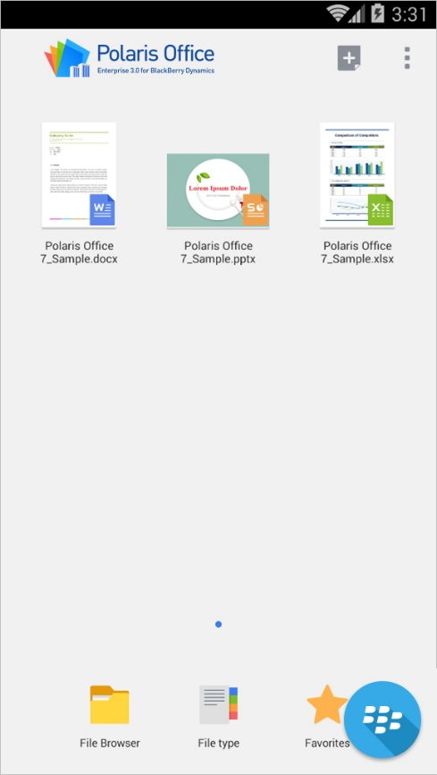

1. File Browser
   * + Tap the 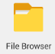 icon located at the bottom of the Home Screen to explore all files and folders in local storage.

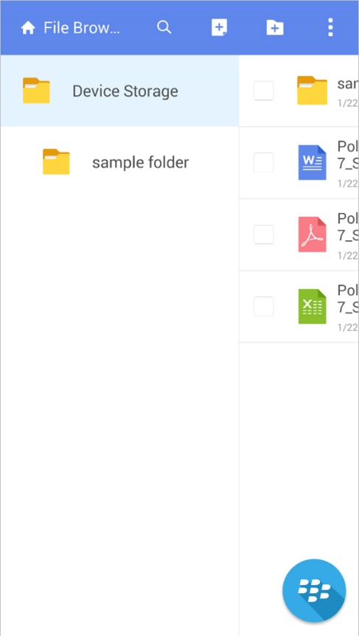

1. View by Document Type
   * + Tap the  icon located at the bottom of the Home Screen to view all local documents by type. There are five document types - MS Word, MS Excel, MS PowerPoint, Adobe PDF, and Text.
2. Favorite
   * + Tap the  icon located at the bottom of the Home Screen to view the list of files marked as "favorite" documents.
     + You can add a file to your Favorites by tapping the star beside the file name.
3. File Management
4. Create New Document
   * + Tap the  icon on the Home screen or the file browser to create new document. You can create 4 types of the document - Word, Sheet, Slide, Text.
5. Create New Folder
   * + Tap the  icon on the top of the file browser and enter the name of the new folder. The new folder will be created in the current location.
6. Move/Copy/Delete/Share File and Folder
   * + Select the  checkbox to the left of the file browser and then tap the , , or  icon at the top of the screen to copy, move, and paste the selected files respectively.
     + Tap the  icon to delete or send files, or to view file information.

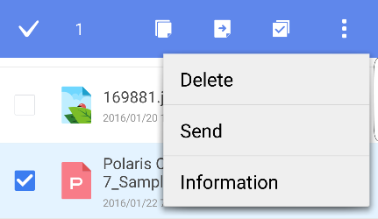

1. View File and Folder Information

* Tap the  icon and then tap ‘Information’ to view the file format, location, size, and last modified date.

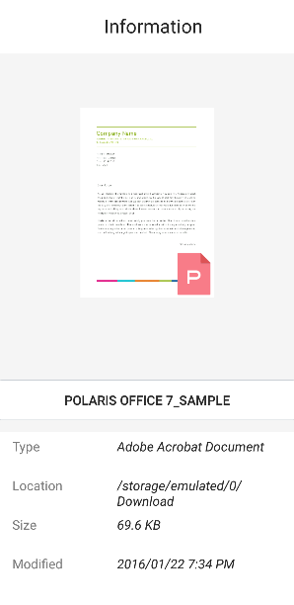

1. View Mode
2. Overview
   * + POLARIS OFFICE for Blackberry provides View Mode and Edit Mode. The mode can be changed in the Settings menu. A new document is created in Edit mode by default.

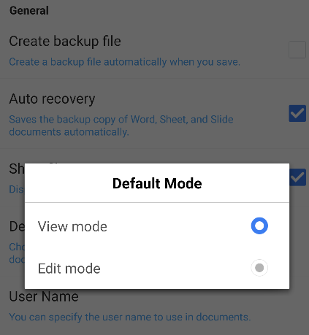

1. Switch Mode
   * + Slide the menu bar on the top of the file to switch the mode. Or Tap the  icon on the top and then select ‘Switch to Edit Mode’ to switch the mode.

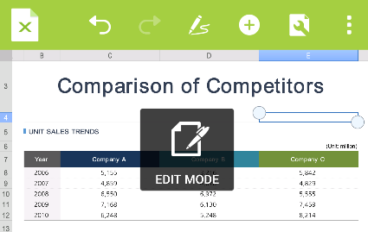

1. Free Handwriting
   * + Tap the  icon at the top of the screen and then write on the screen using your finger.

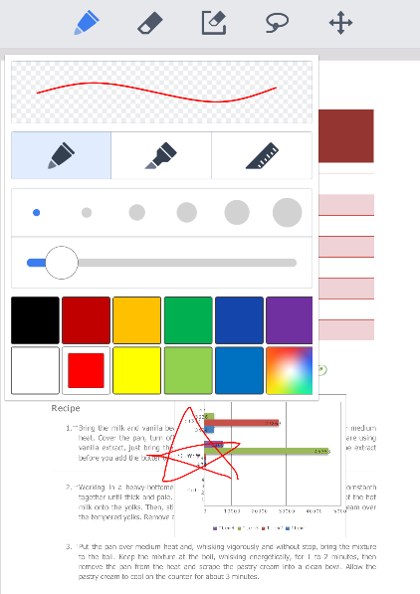

1. Find
   * + Tap the  icon on the top to search through the document. Tap the  icon on the top of the Search Bar to select the option: 'Match Case' or ‘Whole word’. If you select ‘Whole word’, only the words which completely match the search words are displayed.

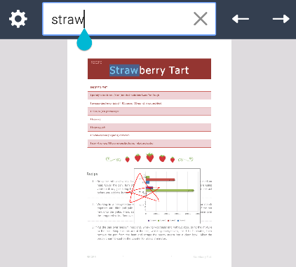

1. Save Document
   * + Save the document as the corresponding Office format or PDF format.

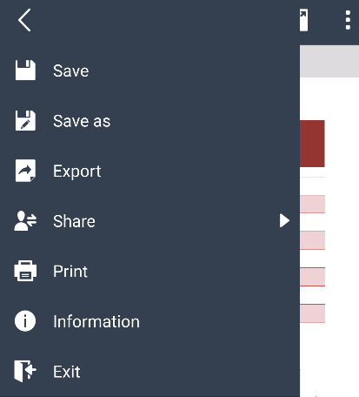 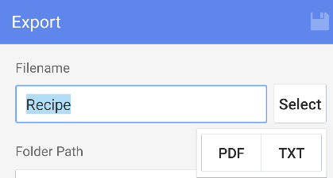

1. Send File

Tap the icon of each document format and then select 'Export' to export the displayed document in various formats. A Document file can be exported as a PDF or text file, a Sheet file as a PDF file, and a Slide file as a PDF or PPSX file.

1. Edit Mode(Edit Features)
2. Select Text
   * + Tap twice and move the left/right pointer on the word or paragraph to adjust the selection area accurately.

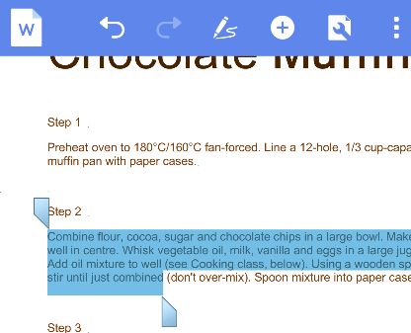

* + - Tab the text area once to display a pop-up menu. Tap the  icon in the pop-up menu to select the entire text.

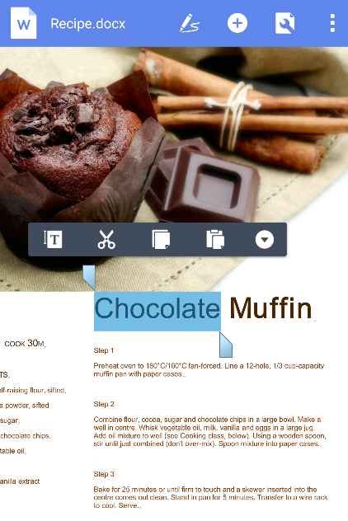

1. Edit Text
   * + When you select text, Cut/Copy/Paste context menu will appear. Select ‘ Cut’, ‘ Copy’, ‘ Paste’ icon to cut, copy, or paste the text.
     + Tap the  icon in the pop-up menu to use additional features such as Copy Format, Clear Format, Share and Search

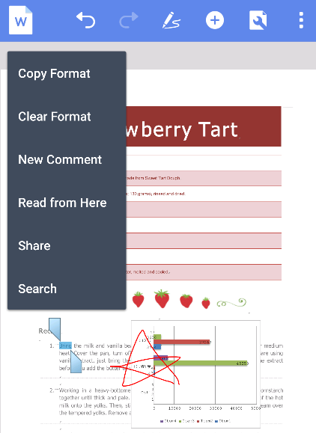

1. Font Format
   * + Select the text and then tap the  icon. The Property panel appears at the bottom. On the Font tab, you can set Font Size, Color, Effects, Font, and Background Color.

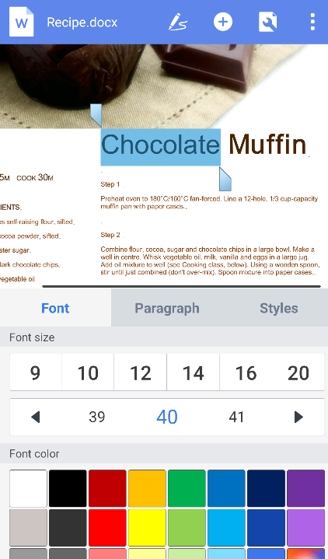

1. Insert Image
   * + Tap the  icon on the top and then select the  icon to insert image saved in the Gallery. Select the  icon to insert the image taken by the camera.
2. Image Format
   * + Select image and tap the  icon to display Property panel at the bottom. On the Format Style tab, you can set Border, Transparency, Shadow/Reflection/Neon/3D Rotation, Alignment, Brightness, Contrast, and Style.

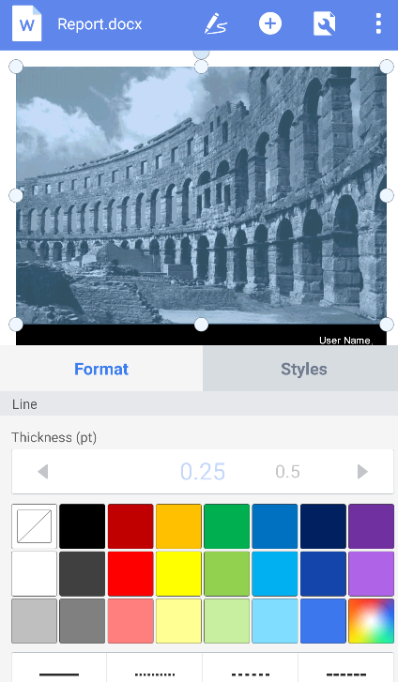

1. Edit Image
   * + Tab image to display pop-up menu. You can cut, copy, delete, replace, or crop the image via pop-up menu.

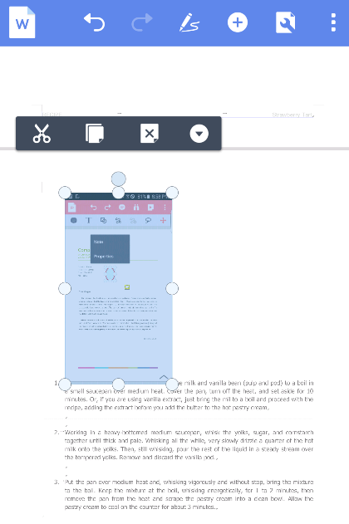

* + - When you crop the image, the area to be cropped is displayed. Tap another area to crop the image. When you select Crop menu again after cropping the image, the original image will be displayed. You can select the area again.

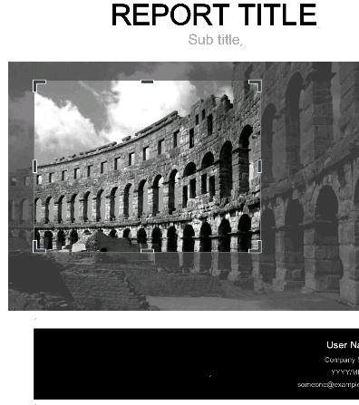

1. Insert Shape
   * + Tap the  icon on the top and then select the D:\1_상품기획팀\1. Office 5 Android\매뉴얼\image\Phone\popover_ico_shape_normal.png icon to insert shape. On Property panel at the bottom, select shape you want and insert it into the document. Before selecting shape, you can predefine the shape style on the Format Style tab of Property panel.

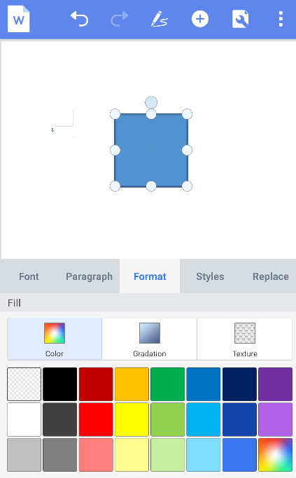

* + - Select the  shape to draw a free line as dragging on the document.

1. Edit Shape Format
   * + Select shape and then tap the  icon. Property panel appears at the bottom. On the menu, you can set the font and paragraph style of the text in the shape, Fill Color, Border Width, Border Color, Effects, Arrange, and Style and replace the shape with others.
2. Insert Table
   * + Tap the  icon on the top and then select the icon to insert table. Select Row/Column and then tap the  icon to insert table.

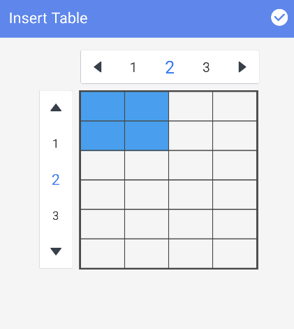

1. Table Format
   * + Select table and tap the  icon to display Property panel at the bottom. On the menu, you can change the text font, paragraph style, table format, and table style.

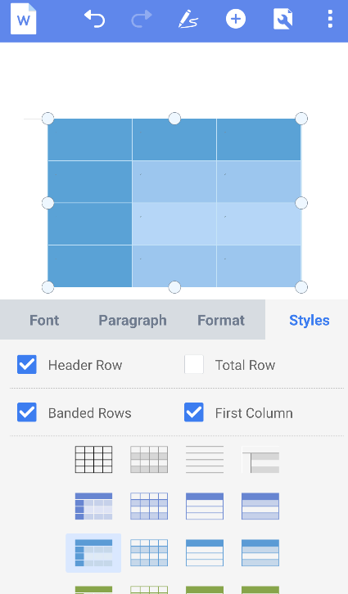

1. Insert Chart
   * + Tap the  icon on the top and then select the  icon to insert chart. Select the chart type you want to insert.

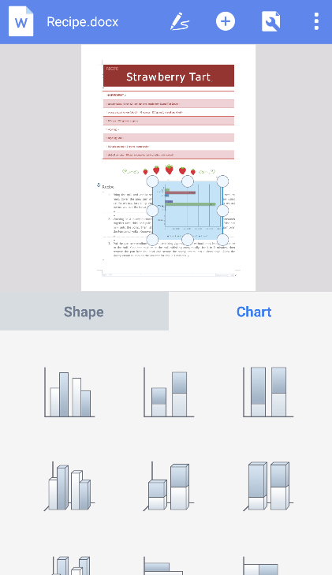 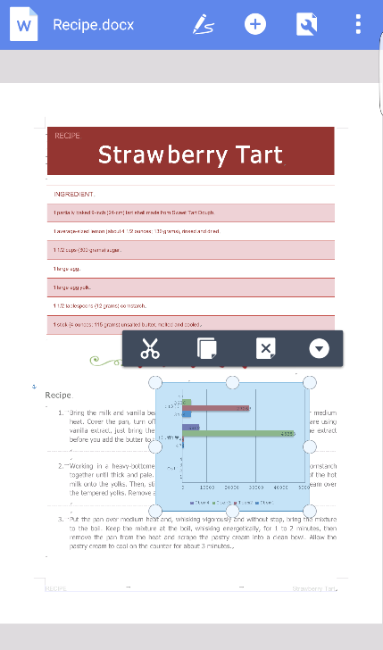

1. Edit Chart Format
   * + Select the chart and then tap the  icon. The Property panel appears at the bottom. You can set Chart Appearance, Layout, Format, and Style.

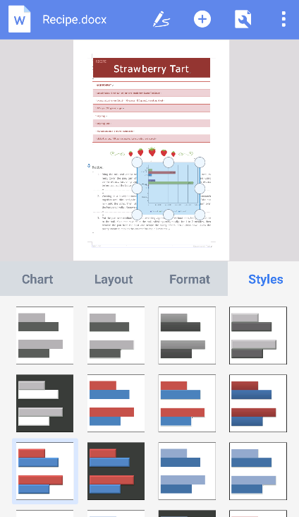

* + - Tab the chart once to display pop-up menu. In the pop-up menu, select ‘Data Sheet’ to edit the data. Double tap the chart to view datasheet directly.

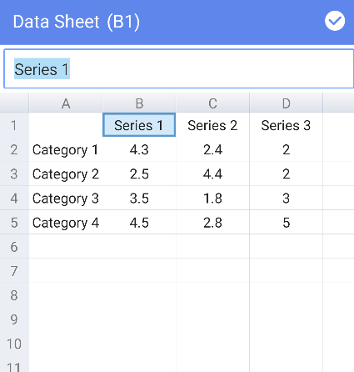

1. Select Multiple Objects
   * + Long-press the image, shape, chart, or objects to change the mode to 'Multi Select' mode. Simultaneously tap the objects you want to select. You can adjust size or move the selected multiple objects.
     + After selecting objects, tap the  icon at the right-hand top corner to align the selected objects.

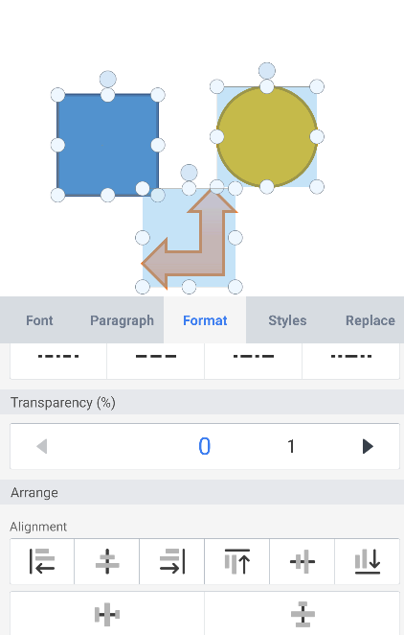

1. Draw Shape/Table with Pen
   * + Tap the  icon at the top corner and then select the  icon to draw a shape with Pen. You can draw Line, Circle, Rectangle, Triangle, Pentagon, Hexagon, Cross, and Star.
     + Select the  icon to draw a table with the Pen. Tap the icon once more and select 'Delete Table' to delete the row/column/border, or to merge cells.

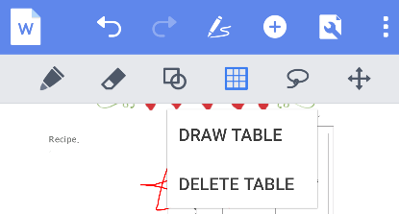

1. Edit Word
2. Overview
   * + Polaris Office Premium allows you to create a new document (.doc or .docx) or easily edit one. However, the format of new document is provided as .docx only.
3. Paragraph Format
   * + Select the text and then tap the  icon. The Property panel appears at the bottom. On the Paragraph tab, you can set Alignment, Bullet/Numbers, Indent, Line Spacing, Paragraph Spacing, and Text Flow.

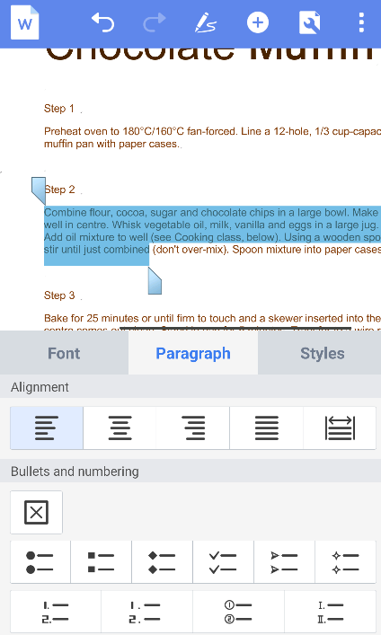

1. Style Format
   * + Select the text and then tap the  icon. The Property panel appears at the bottom. In the Styles tab, you can choose from 16 text formats, including Standard, No Spacing, Emphasis, and Reference.

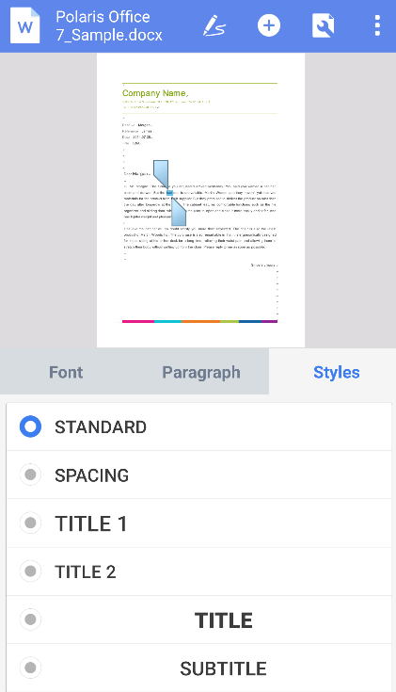

1. Insert Memo and Edit
   * + Tap on the screen where you want to insert a memo. A pop-up menu will then appear. In the pop-up menu, select ‘New Comment’ to insert a memo in the desired position.
     + Tap the area where the memo has been inserted. A pop-up menu will then appear. In the pop-up menu, select 'Edit Comment' to edit the memo.
     + In the Memo window, tap the arrow icon to move to the previous/next memo. Tap the  icon to select the memo you want to delete. You can choose to delete the current memo or all of the memos on the page.

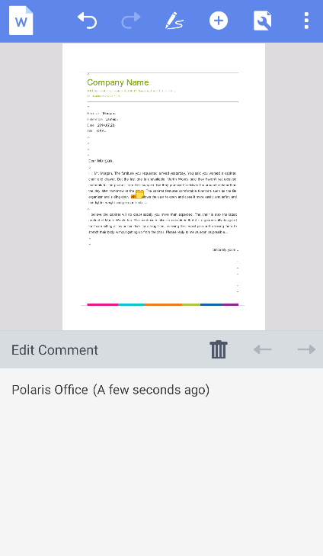

1. Insert Header/Footer/Footnote/Endnote
   * + Tap the  icon at the top of the screen, and select the  icon to display the More menu. In the More menu, select ‘Header/Footer’ to insert a header, footer, page number, footnote, or endnote. You can insert text and images in the header/footer.ㅍ

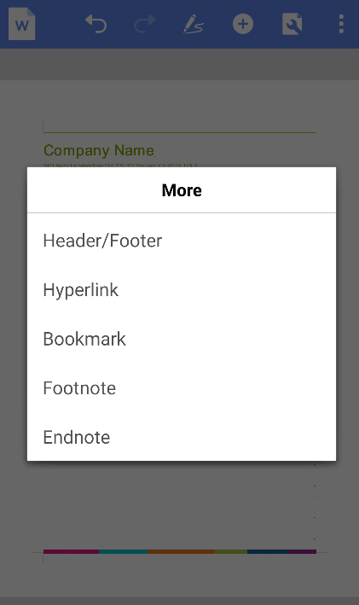 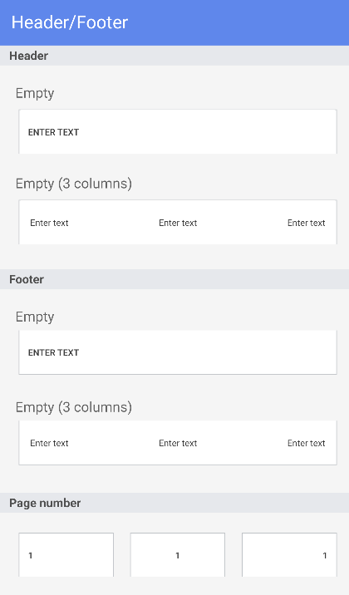

* + - Place the cursor on the position where the footnote will be inserted, tap the  icon on the top, and select the  icon to display More menu. On More menu, select ‘Footnote’ or ‘Endnote’ to insert the footnote or endnote. The footnote is displayed at the bottom of the page and the endnote is displayed at the end of the document.

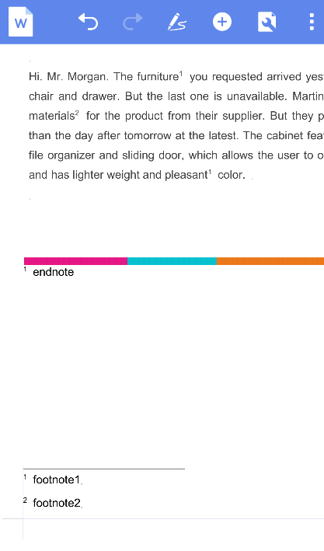

* + - When you delete the footnote/endnote number in the body text, the footnote/endnote inserted at the bottom of the page and at the end of the document is deleted together.

1. Find/Replace
   * + Tap the  icon at the top of the screen to search through the document using Find/Replace. Tap the  icon in the top left-hand corner of the search window to set the 'Match case,' 'Whole words only', or 'Match half/full width forms' options, or to switch to Replace mode.

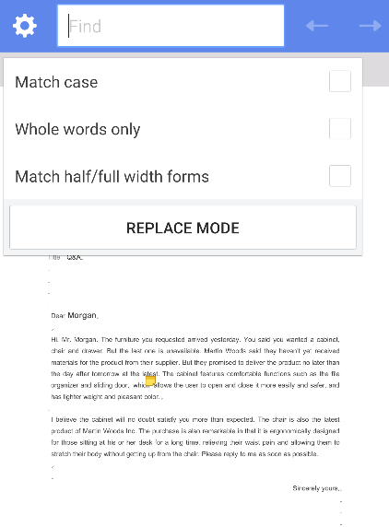

1. Set Document Layout
   * + Tap the  icon in the top right-hand corner of the screen and then tap the ‘Page Layout’ button to set the document layout. You can set the margins, size, orientation, and columns of the document, break the page or section, and specify the range of pages to apply the setting to.

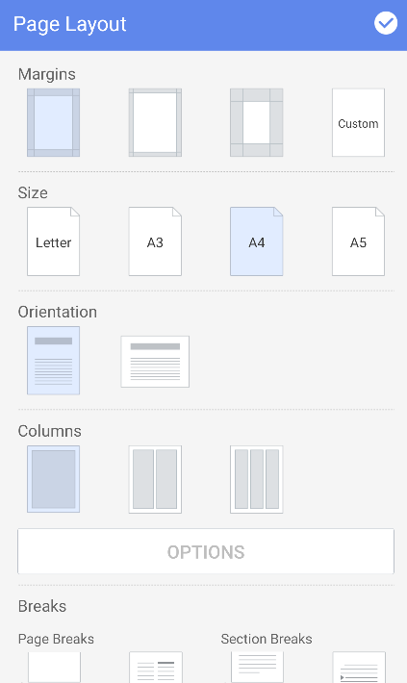

1. Set Document Background
   * + Tap the  icon in the top right-hand corner of the screen and then tap the ‘Background’ button to set the format of the document background.
     + In the Watermark tab, you can insert or remove a watermark from the document.

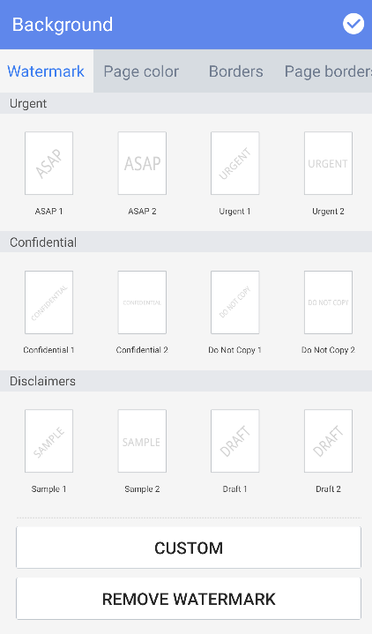

* + - In the Page color tab, you can select a document background color, set the gradation, and insert images.

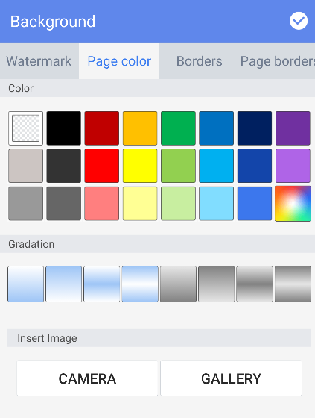

* + - In the Borders tab, you can set the border style for the selected text or paragraph in the document.

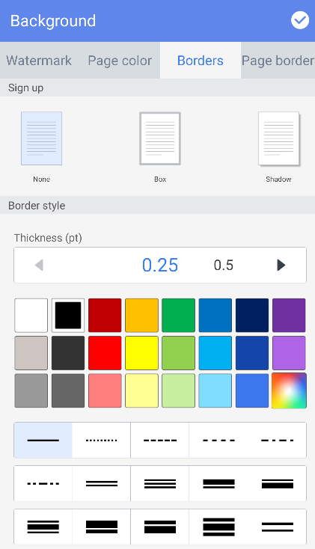

* + - In the Page borders tab, you can set the border style for the entire document.

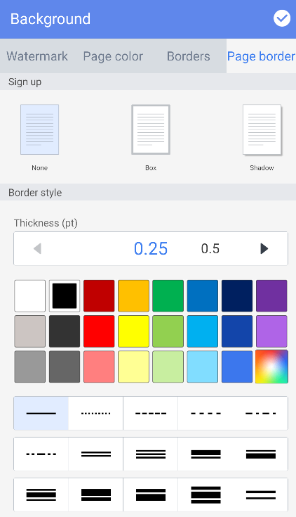

1. Track Changes
   * + The Track Changes feature allows you to view changes to the document, such as inserted or removed content.
     + Tap the  icon in the top right-hand corner of the screen and then tap the ‘Track changes options’ button to set track changes options. After setting the options, select 'Track Changes' to display the changes to the document. Select 'Disable Change Tracking' to end tracking.

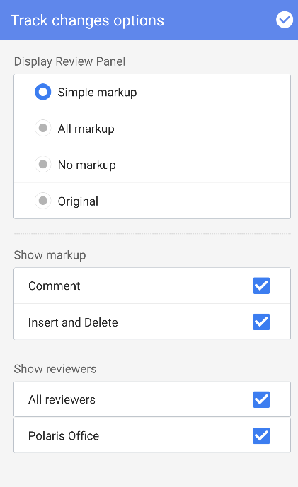 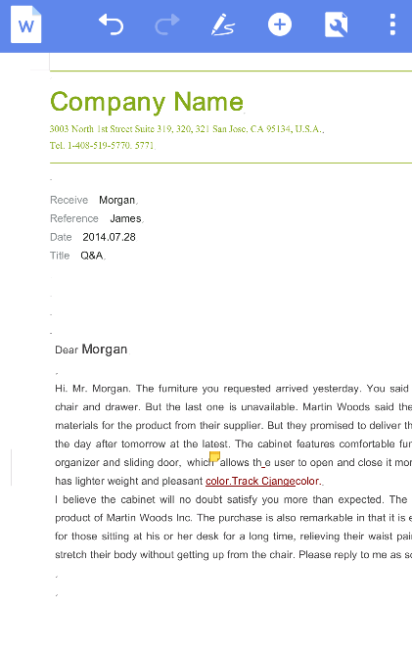

1. View Settings
   * + Tap the  icon in the top right-hand corner of the screen and then tap the ‘View Settings’ button to set the document view. You can set the view to 'Show Ruler', 'Full width view', and 'Rearrange Text'.

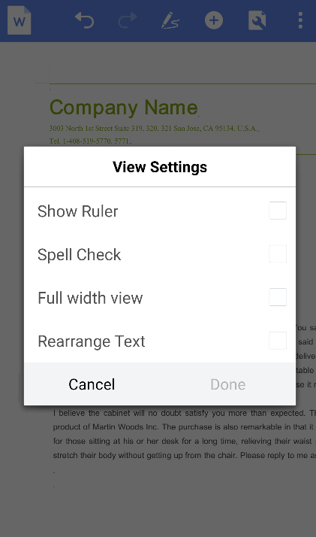

1. Other Features
   * + Tap the  icon in the top right-hand corner of the screen to read the document from the beginning or to move to the desired page.
     + Tap the ‘Read All’ button to hear the document content read aloud from the beginning.

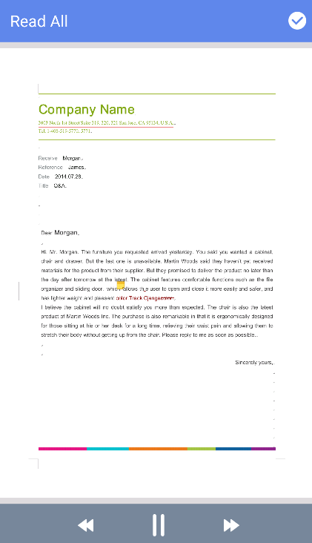

* + - Tap the ‘Go to Page’ button and enter the desired page number to move to a page directly.

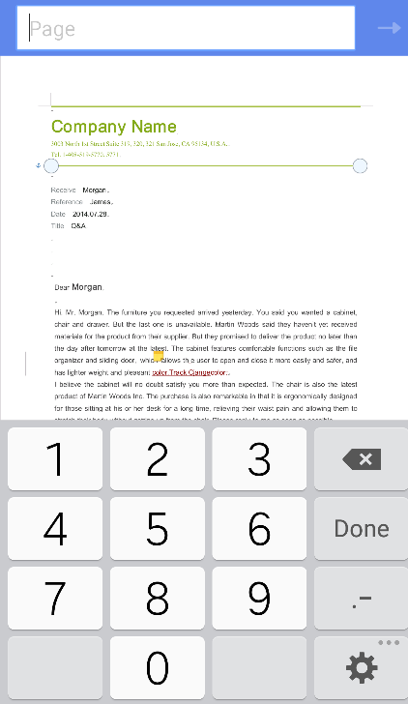

1. Edit Sheet
2. Overview
   * + Polaris Office Premium allows you to easily create a new document (.xls or .xlsx) or edit an existing document. However, the format of new documents is provided as .xlsx only.
3. Select Cell
   * + Tap a cell once to select it. Tap a cell twice to enter data in the format input window at the top of the screen. The data entered into the window is displayed on the cell in real time.

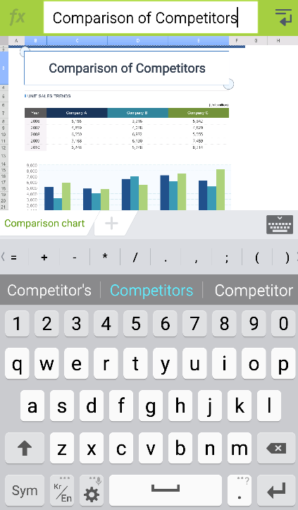

1. Edit Cell
   * + Select a cell and then tap the pointer to display a pop-up menu. In the pop-up menu, tap the , , or  icon to cut, copy, or paste the data in the cell respectively.
2. Edit Rows/Columns
   * + Select a row or column and then tap the pointer to display a pop-up menu. In the pop-up menu, tap the  icon to insert or delete the row/column or auto-size the row/column.

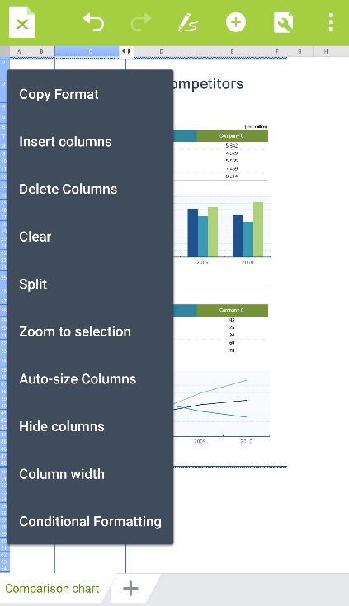

1. Add Memo and Edit
   * + Tap on the screen where you want to insert a memo. A pop-up menu will then appear. In the pop-up menu, select ‘New Comment’ to insert a memo in the desired position.
     + Tap the area where the memo has been inserted to display a pop-up menu. In the pop-up menu, select 'Edit Comment' to edit the memo.
     + In the Memo window, tap the arrow icon to move to the previous/next memo. Tap the  icon to select the memo you want to delete. You can choose to delete the current memo or all of the memos on the page.

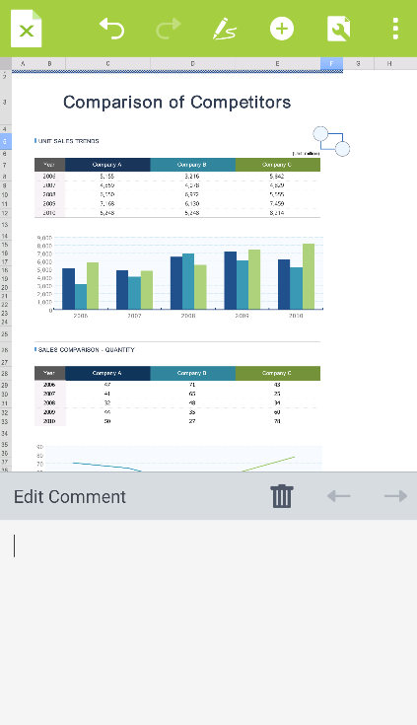

1. Compose Formula
   * + Select a cell where the formula will be inserted and then tap the  icon at the left of the format input window. You can see the list of functions. On the top of the list of functions, you can directly execute Sum, Mean, Count Nums, Max, and Min operations and select the other functions in the following list.

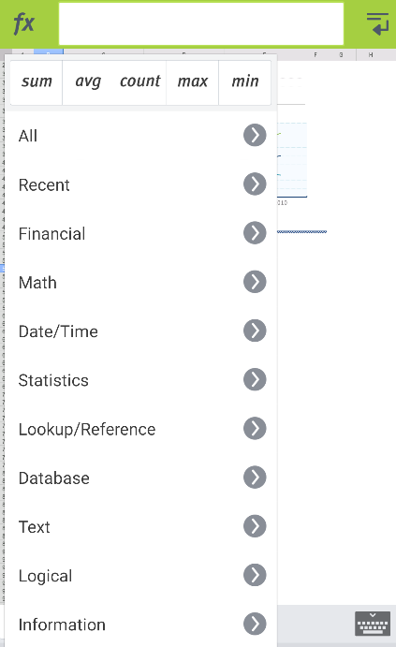

1. Alignment/Number Format
   * + Select a cell and then tap the  icon at the top of the screen to display the Property panel at the bottom. In each tab, you can set the Font, Alignment, Number Format, and Cell Format options. When you select Setting Options, the settings are applied to the cell in real time.
     + In the Alignment tab, you can set the alignment of the cell to Left/Center/Right and Top/Middle/Bottom, and Wrap text in a cell.

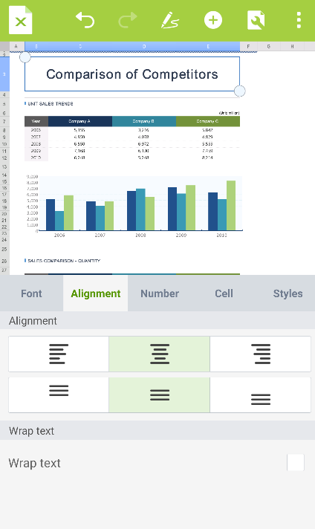

* + - In the Number format tab, you can set the cell number settings such as the Number, Currency, Accounting, Date, Time, Percentage, Fraction, Scientific, and Text.

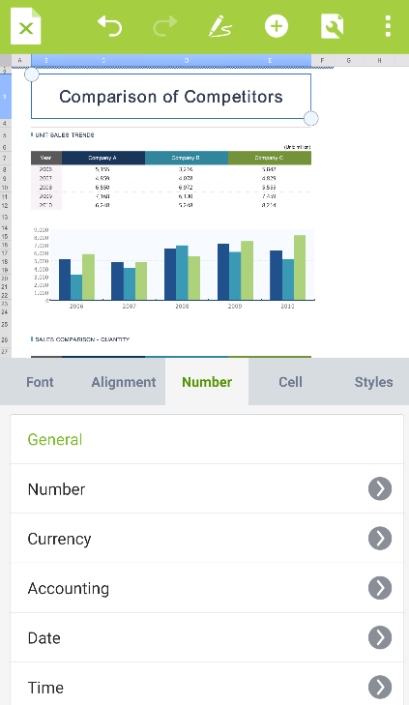 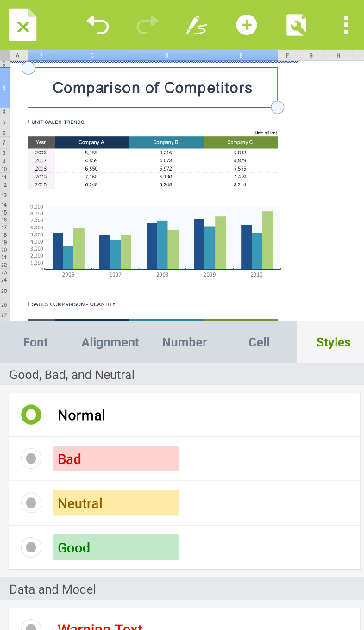

1. Cell Format
   * + On the Cell Format tab, you can set Fill Color, Border Color, and Border Width.

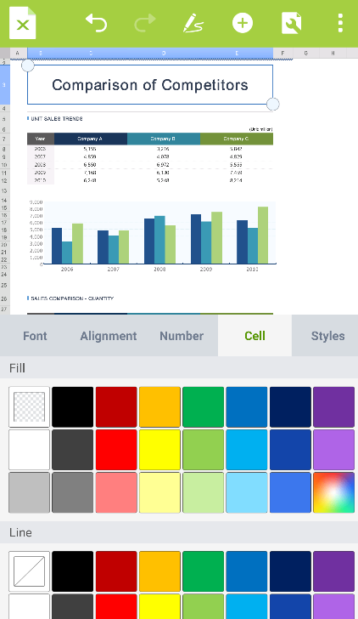

1. Conditional Format
   * + Select a cell to apply a conditional format to and tap the pointer to display a pop-up menu. In the pop-up menu, tap the  icon to select 'Conditional Formatting’. In the Property panel of the Conditional Formatting screen, select rules, such as Highlight Cells Rules, Top/Bottom Rules, Data Bars, Colors, and Icon Sets, to apply conditional formats to the document.

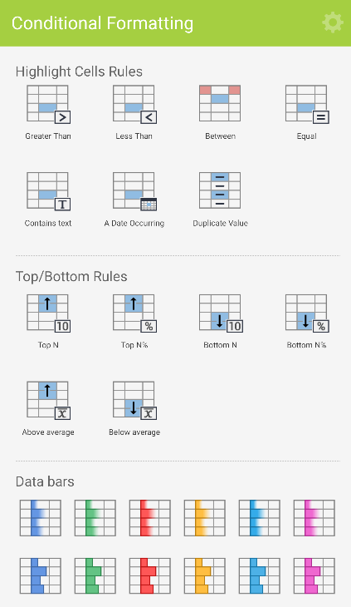

1. Insert Table
   * + Select the range of cells where you want to insert a table and then tap the  icon at the top of the screen to select the  icon.

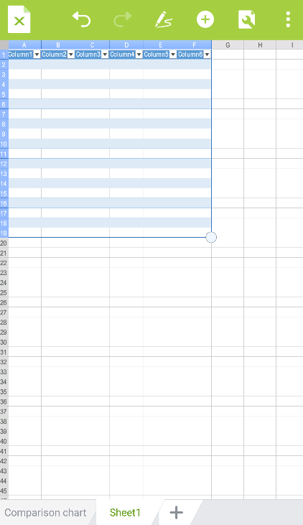

1. Table Format and Edit
   * + Select a table and tap the  icon at the top of the screen to display the Number panel at the bottom. In the Number panel, you can set various types of number format settings.

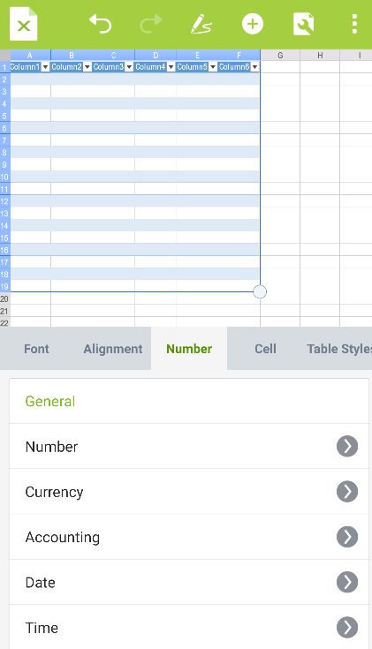

* + - Select a table and tap the  icon at the top of the screen to display the Table Style panel at the bottom. In the Table Style panel, you can preview and set various table styles.

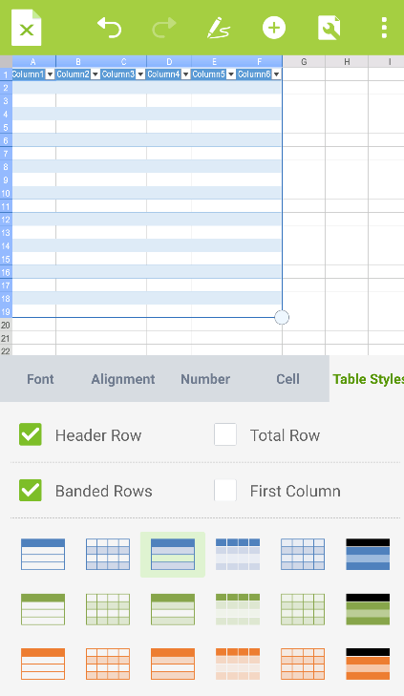

1. Filter/Sort/Freeze Panes
   * + Select a cell or several cells and then tap the  icon at the the top of the screen to apply the Filter, Sort, and Freeze Pane features.
     + Select the cell you want to apply a filter to, tap the  icon, and then select the Filter menu. The filter is then applied to the cell and you can select the filter conditions by tapping the filter arrow displayed on the cell.

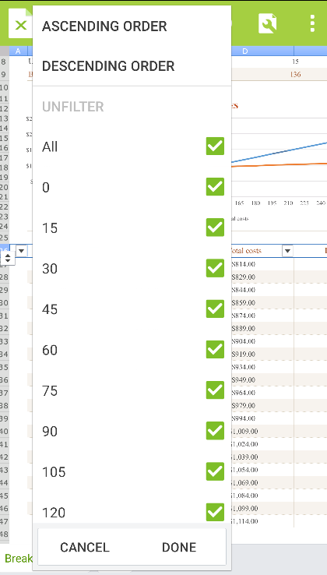

* + - Select a cell range to sort, tap the  icon, and then select the Sort menu to set the Sort by and Sort Direction settings.

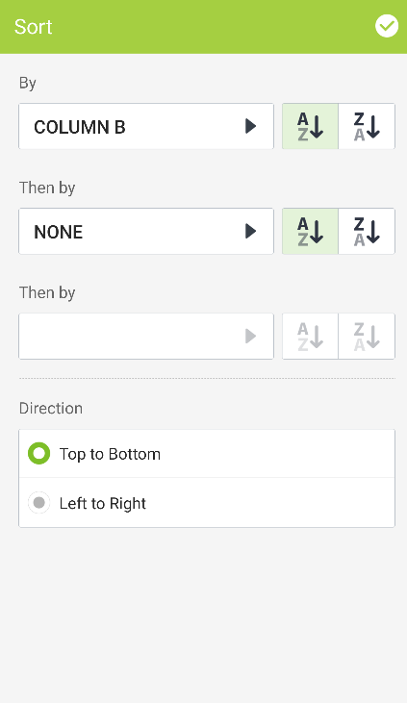

* + - Select a cell range to freeze and then tap the  icon at the top of the screen to apply the Freeze Pane feature. To unfreeze the cells, select the cells where Freeze Panes has been applied, tap the  icon again, and then select Unfreeze panes from the menu.

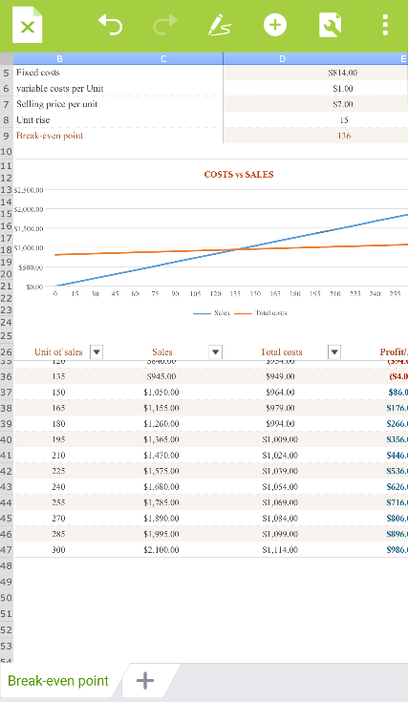

1. Edit Worksheet
   * + Tap the worksheet at the bottom of the sheet to display a pop-up menu. In the pop-up menu, you can add, copy, or delete a worksheet.

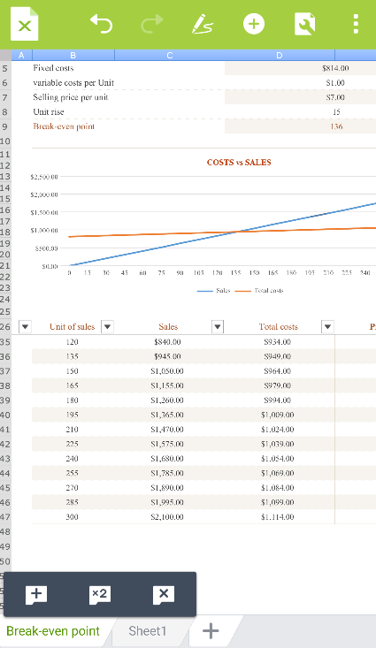

* + - Tap the text of the worksheet twice to rename the worksheet.

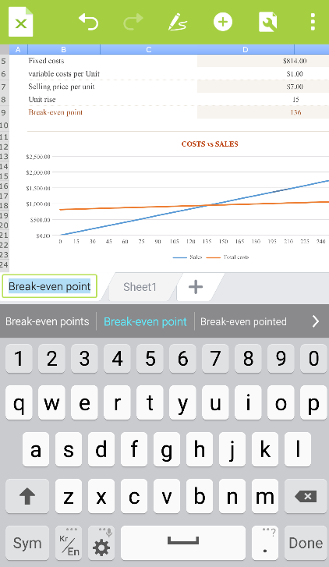

* + - While the worksheet to protect is displayed, tap the  icon at the top of the screen and then select 'Protect Worksheet' from the menu to prevent the worksheet from being edited. Select 'Unprotect Worksheet' from the top menu to edit the sheet.

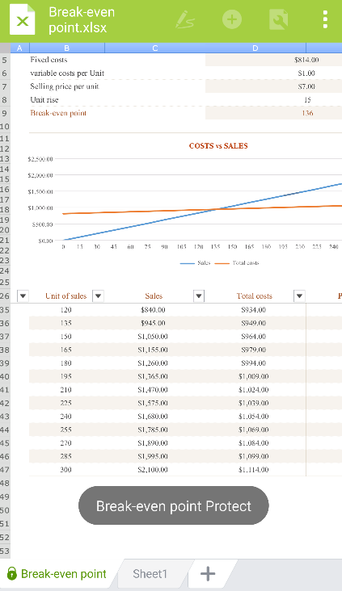

1. Edit Slide
2. Overview
   * + Polaris Office Premium allows you to easily create a new document (.ppt or .pptx) or edit an existing document. However, the format of new documents is provided as .pptx only.
3. Add Slide
   * + Tap the  icon at the bottom to add slide. Select the layout you want and then the slide with the selected layout will be inserted after the current slide.

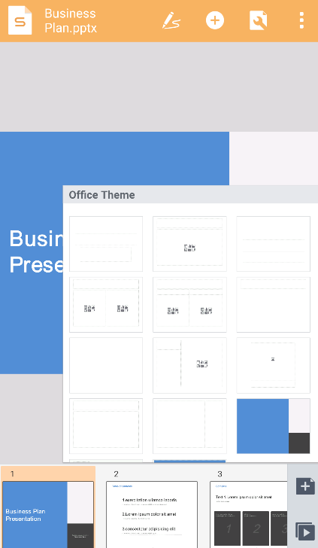

1. Edit Slide
   * + Tap a slide twice on the slide list to display a pop-up menu. In the pop-up menu, tap the , , or  icon to cut, copy, or delete a slide respectively. To duplicate, hide, and change the layout and background of slides, tap the  icon to display the More Menu and then select the desired option.

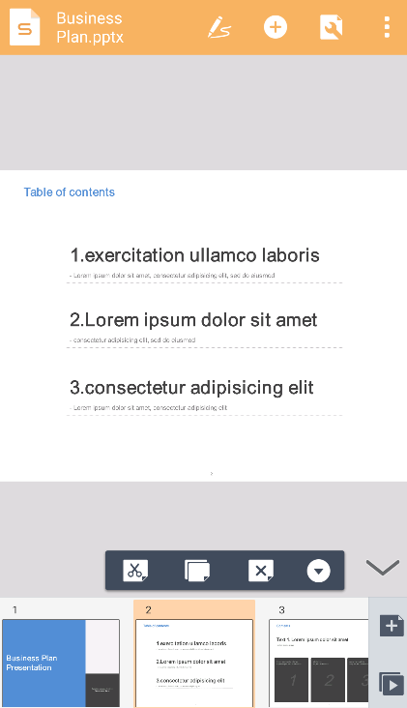

1. Show Slide
   * + Tap the  icon at the bottom to switch the screen to the Slideshow screen. To move page, tap the slide, use the horizontal scroll bar at the bottom, or tap the  or  icon at the left/right side of the scroll bar.
     + To use a pointer or add note with Ink Pen on the document during slideshow, select the  icon at the left-hand top corner of the slide.
     + Select the icon to use pointer or change the pointer color. Select the  icon to draw or erase notes or lines or change the type, color, and thickness of the Pen.

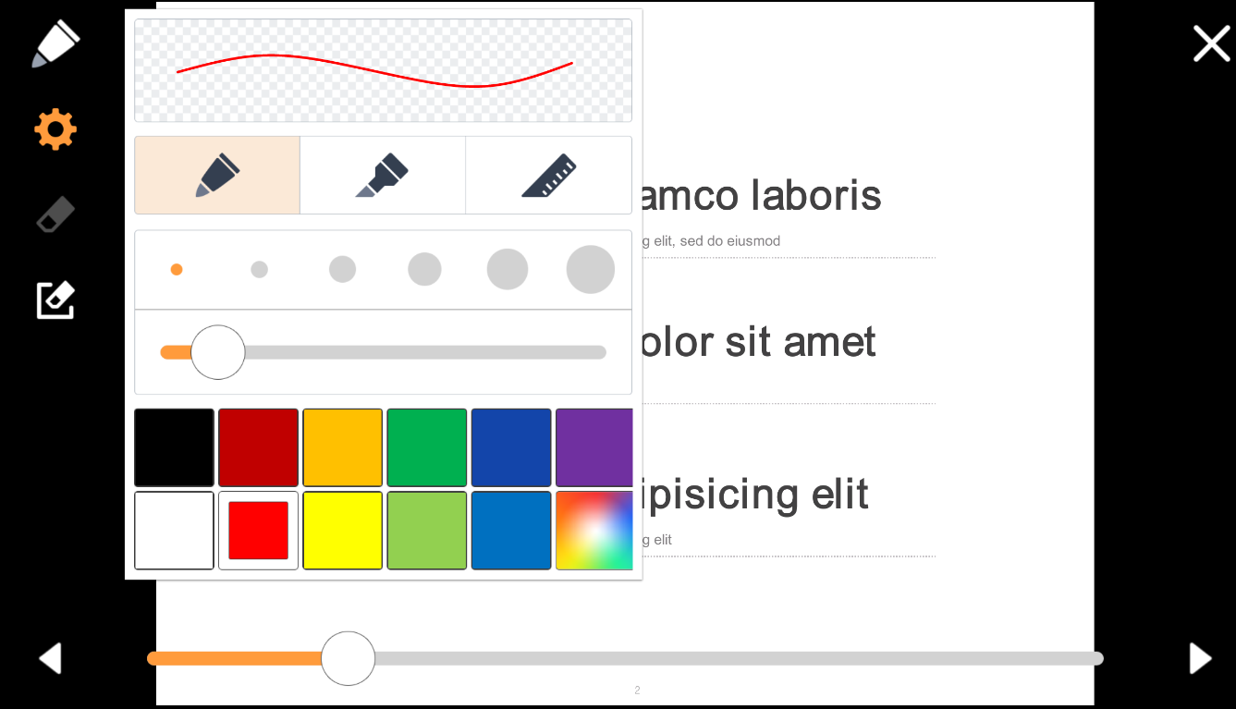

1. Slide Note
   * + Tap the  icon at the top of the screen to display a pop-up menu. In the pop-up menu, select Slide Note to display a note window, in which you can enter text, at the bottom of the slide.

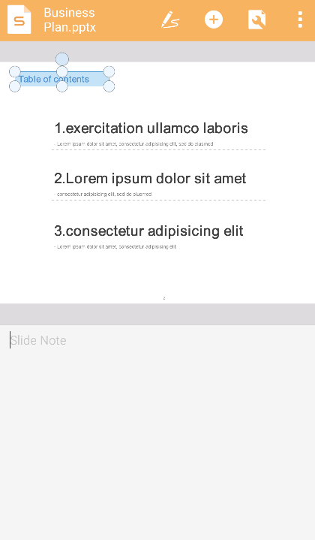

1. Insert Memo and Edit
   * + Tap the screen where you want to insert a memo to display a pop-up menu.. In the pop-up menu, tap  and then select ‘New Comment’ to insert a memo in the desired position.

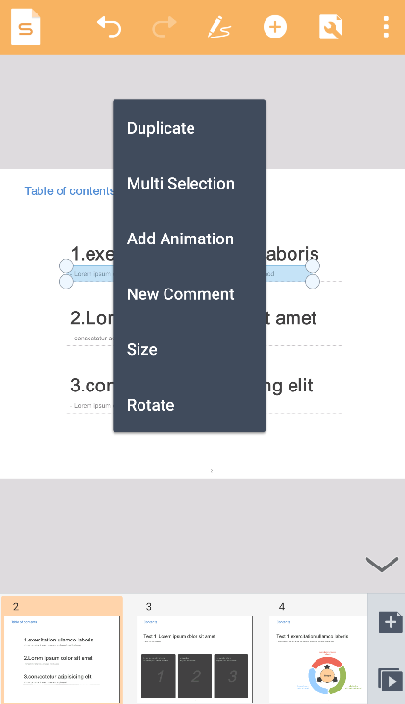

* + - Tap the area where the memo has been inserted to display a pop-up menu. In the pop-up menu, select the  icon to edit the memo.

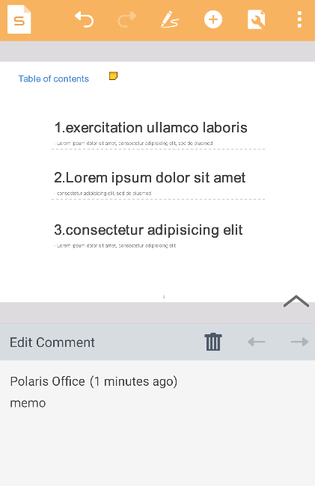

1. Insert Text Box
   * + Tap the  icon at the top of the screen and then tap the  icon to insert a horizontal text box, or tap the  icon to insert a vertical text box.

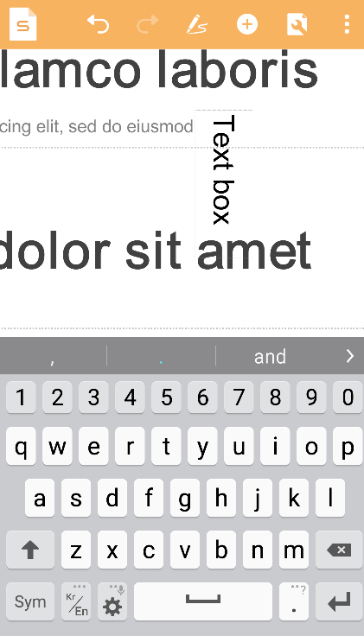

1. Insert Video
   * + Tap the  icon at the top of the screen and then tap the  icon to insert a video you have taken with the camera into the slide.
     + Tap the  icon at the top of the screen, enter the URL in the field next to the  icon, and then tap the  icon to insert a video from the Internet into the slide.
     + 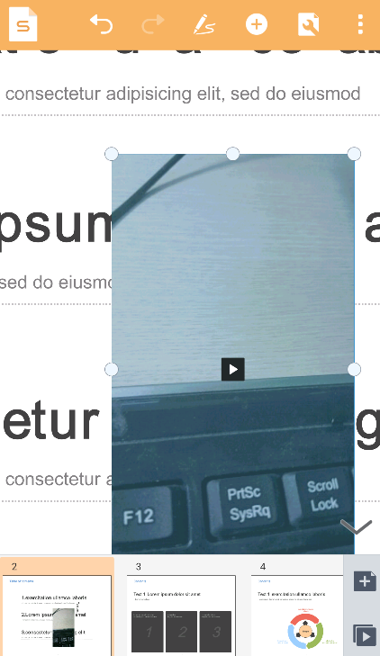
     + The video inserted into the slide can be played back, paused, and stopped while the Slideshow is being executed.
2. Add Object Animation
   * + Tap an object where an animation will be applied to display a pop-up menu. Tap the  icon in the pop-up menu and then select 'Add Animation'. In the Property panel of Add Animation, you can select and apply animations such as Appear, Emphasis, and Exit.
     + 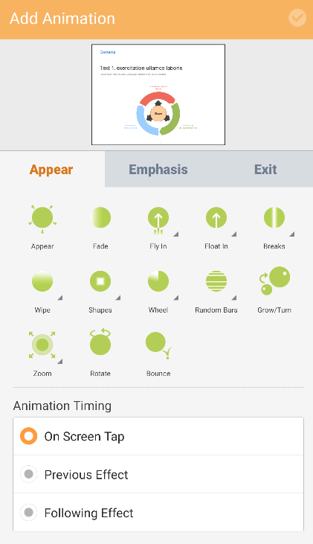 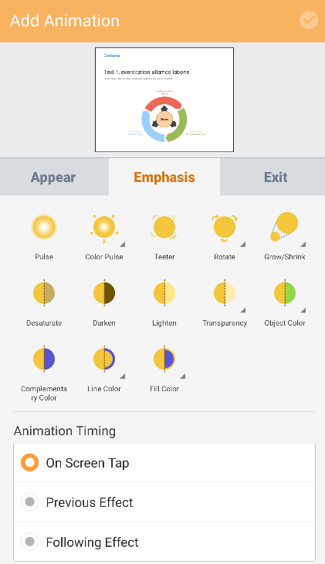 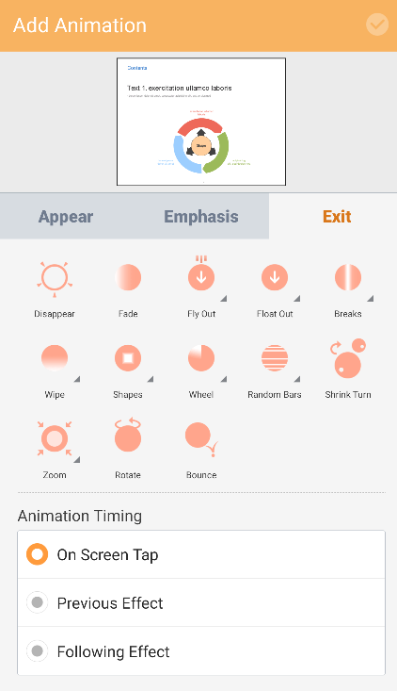
3. Slide Transition Effects
   * + While the slide where Transitions will be applied is displayed, tap the  icon at the top of the screen and then select 'Transitions' to display the Property panel of Transitions. You can apply effects such as Subtle, Splendid, and Dynamic. Tap the Apply to All button to apply the selected effect to all of the slides. You can also set the transition time.

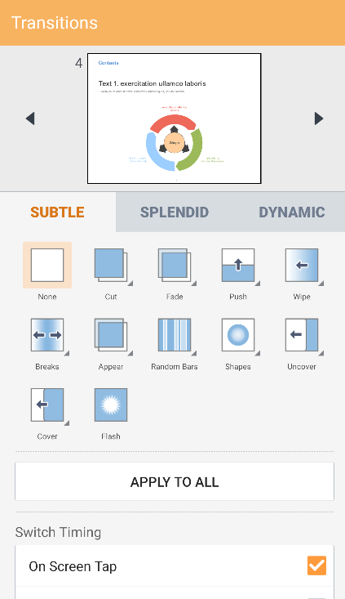 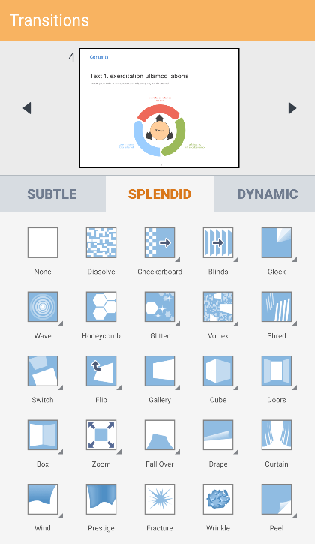 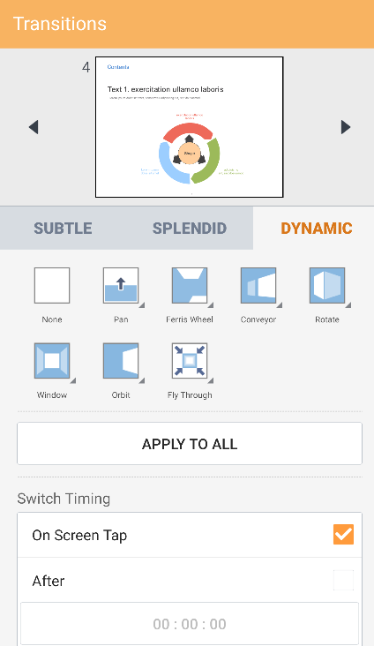

1. Slide Master
   * + While the slide to be edited is displayed, tap the  icon at the top of the screen and select 'Slide Master' to display the Property panel of the Slide Master. You can insert a Slide Master or layout and edit the Slide Master.

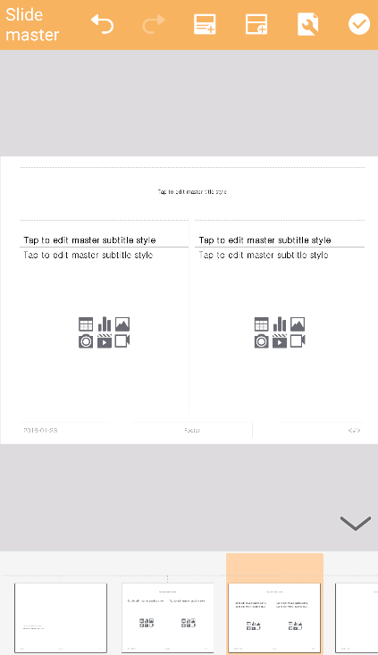 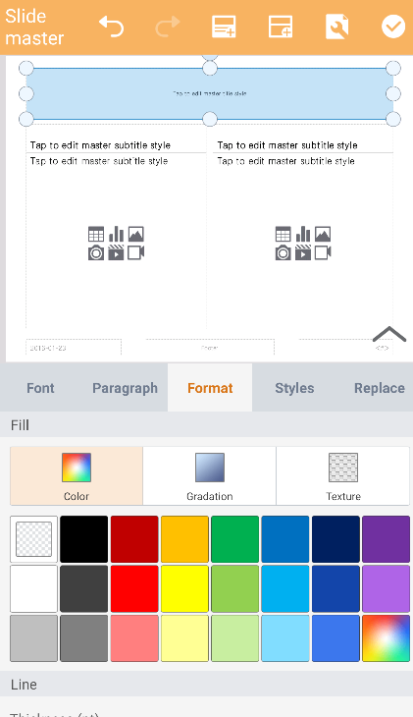

1. View Settings
   * + Tap the  icon at the top of the screen and then tap the 'View Settings' button. In the View Settings pop-up menu, select the ‘Show Smart Guideline’ checkbox. When it is selected, the proper position of the selected shape or image will be displayed as the Smart Guide shows reference lines while you are moving the shape or image.

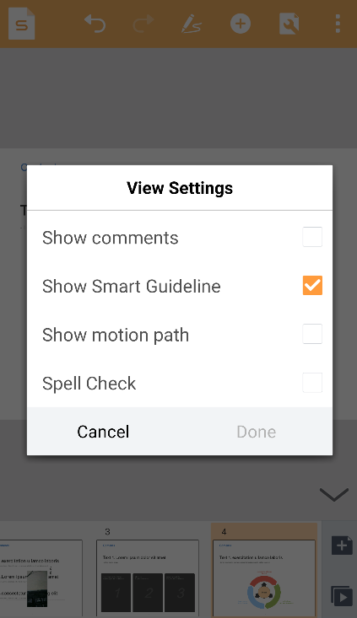

* + - Tap the  icon at the top of the screen and then tap the 'Show Comments' button to display a pop-up menu. The comments written in the document are displayed.
    - Tap the  icon at the top of the screen and then tap the 'View Settings' button. In the View Settings pop-up menu, select the ‘Show motion path’ checkbox. You can then check the order in which animations will be applied to the object.

1. PDF Document
2. Overview
   * POLARIS OFFICE for Blackberry allows you to save Office documents (MS Word, MS Excel, and MS PowerPoint) as .pdf files. You can also use POLARIS OFFICE for Blackberry to insert short notes or annotations in an existing PDF document.
3. Add Memo and Edit
   * + Tap the position in the document where the memo will be inserted and then tap the  icon in the pop-up menu to display the Memo pane at the bottom. After creating a memo, the  icon will be displayed in the document. After selecting the Memo icon, select Properties from the pop-up menu to change the icon color.
     + 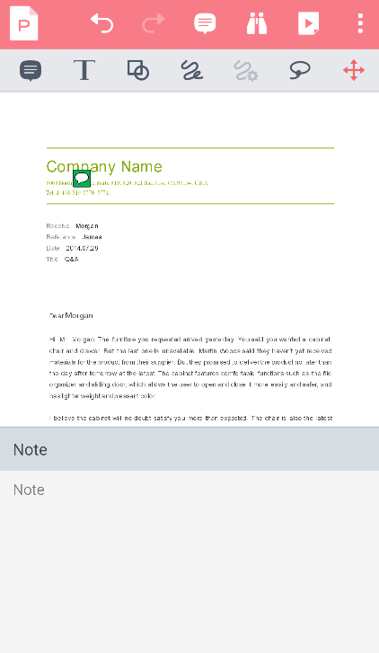 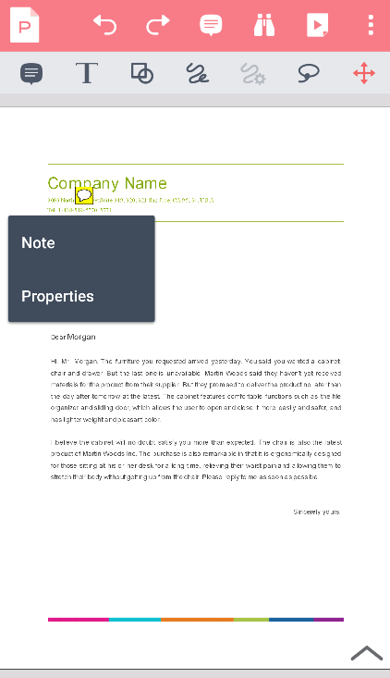
4. Add Annotation and Edit
   * + Tap the  icon at the top of the screen to display the Annotation menu. Tap the  icon to insert a memo.
     + Tap the  icon to highlight, underline, or strikethrough selected text in the PDF document.
     + Tap the  icon to insert a textbox, rectangle, oval, arrow, or line into the PDF document.

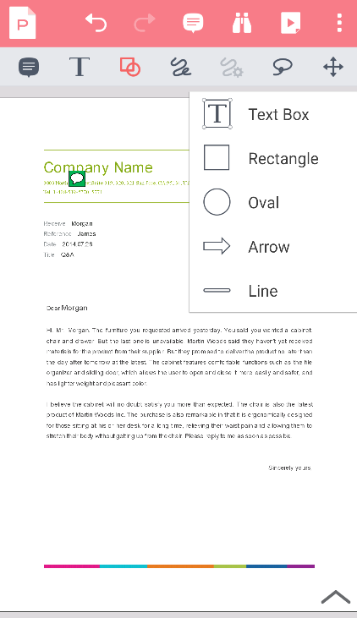

* + - Tap the  icon to draw on the PDF document. Tap the  icon to change the line thickness and color.

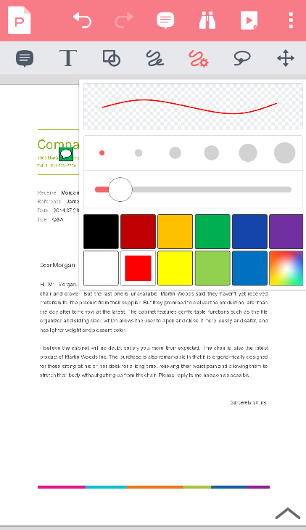

* + - Tap the  icon to select several applied annotations.

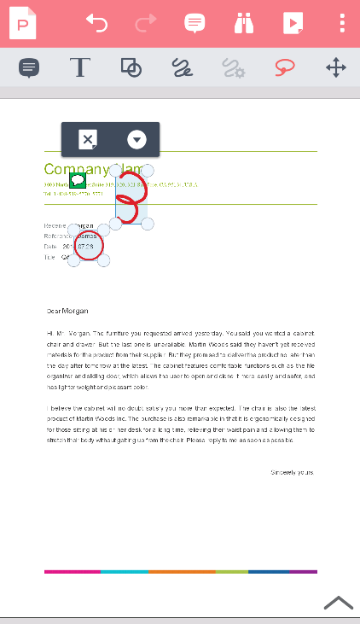

* + - Tap the  icon to move around the displayed page while Annotation is enabled.

1. View Annotation List
   * + Tap the  icon at the top and then tap ‘Annotation List’ to display the list of annotations that have been applied to the document. Tap the annotation on the list to move to the corresponding annotation directly. Tap the  icon, then select the check box to the right of the list to delete the Annotation.

 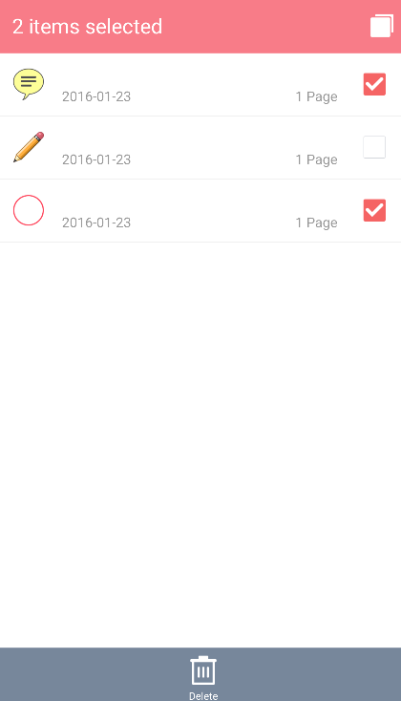

1. PDF Presentation Features
   * + Tap the  icon at the top of the screen to select the range of slides in the Slideshow to be executed. To move page, tap the slide, use the horizontal scroll bar at the bottom, or tap the  icon or the  icon at the left/right side of the scroll bar.
     + To use a pointer or add a note to the document with the Pen during the Slideshow, select the  icon in the top left-hand corner of the slide.
     + Tap the  icon to select the pointer and tap the  icon to change the pointer color.
     + Tap the  icon to write a memo, or to draw or erase an ink line. Tap the  icon to change the type, line thickness, and color of the pen.
2. Other Features
   * + Tap the  icon at the top of the screen and select ‘Show Annotations’ to show or hide annotations in the document. ‘Rearrange Text’ is a feature which fits the displayed document to the screen, while ‘Bookmark’ allows you to view a list of bookmarks inserted in the document.

